**E Tracker Manual**

**Step 1 : Powering the device**

First, insert the SIM card in the SIM holder. A standard SIM card is best suited for the e-Tracker. You can use a micro or nano SIM card along with a SIM card adaptor. You can either power the board from a power adaptor (9V/12V) by connecting it to the EXT terminals (Make sure the supply select switch is in EXT position) or using a Lithium Polymer battery (3.6-4.4V), by connecting it to the BATT terminal (Make sure the supply select switch is in BAT position).

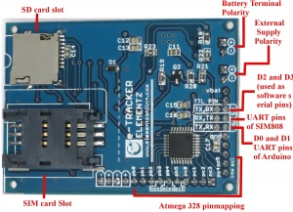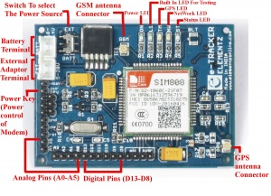

**Step 2 : Uploading the Firmware**

The Firmware hex file which is given to you should be uploaded into the

e tracker for it to start working. The procedure for uploading the hex file is as follows :

First connect the e tracker to the computer using a USB to TTL converter available at our store online. Connect the RX pin of the converter to TX of the Hardware serial of the device. TX pin of the converter is connected to the RX pin of the Hardware serial of the device. The GND and DTR pins of both the devices are connected with each other respectively.

**In Linux** ,

Open the terminal window, then type the following commands in order.

$ : sudo apt-get install avrdude

$ : avrdude -p ATMEGA328P -c arduino -P /dev/ttyUSB1 -b 115200 -D -U flash:w:etracker.ino.hex:i

You should be able to see an indication in the terminal once it has completed uploading.

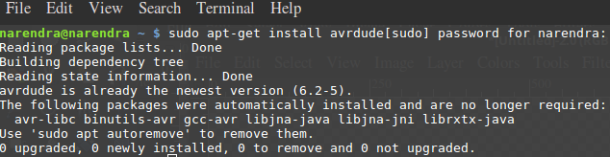

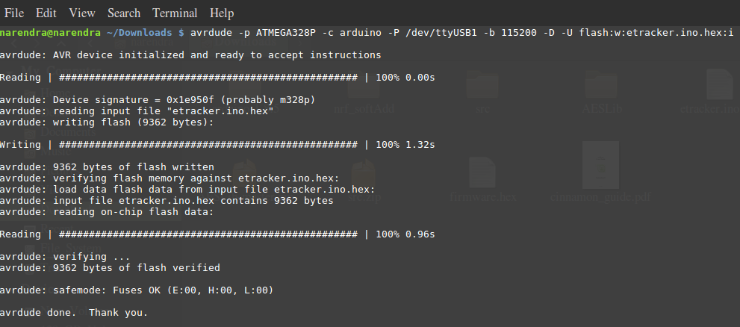

Typical Screenshots are attached for reference.

After uploading the hex file, remove the device from the computer. Then make sure to short both the Hardware serial pins using jumpers as shown.

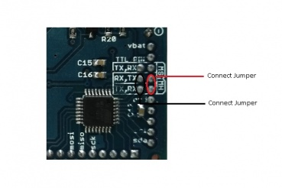

**Step 3 : GPS online tracking site**

After completing the hardware section, open a web browser and log onto

[**http://elementzteam.com:1111/map/tracking**](http://elementzteam.com:1111/map/tracking)

Register yourself in the website. Then select your device using the IMEI number and you can track the device.

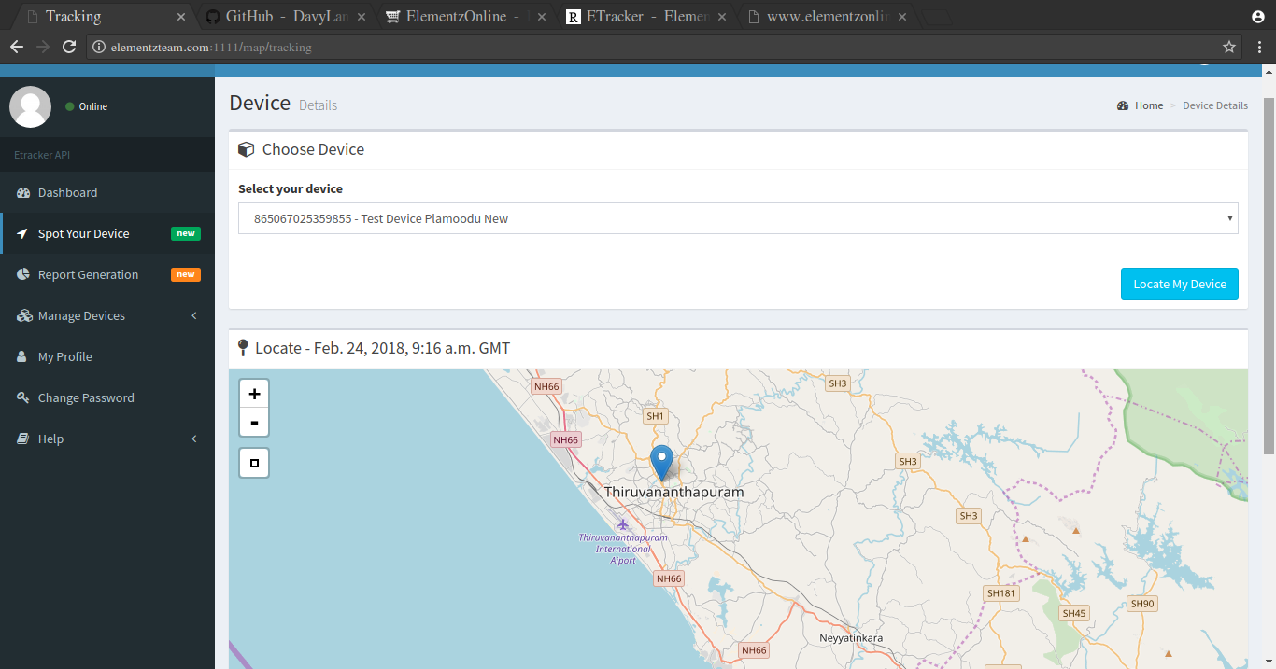

This is a screenshot of the website.

**Troubleshooting**

There are five LED’s present in the device that indicate the status of different features of the device.

They are ON, L1, TM , NW and ST. As the name suggests, ON led indicates whether the device is ON or OFF. TM indicates whether the GPS is working or not. NW blinks slowly if there is GPRS connectivity. ST glows if the modem is working. L1 is spare LED that can be used for coding purposes for the user (digital pin 6 of arduino). The LED’s are highlighted in the figure below.

